Project:
Project Working Title: Simulating the Brownian Dynamics of a Two-Dimensional Model for the Dynein Motor Protein

Project End Date: 10 May 2019 (The end of week 6 of spring term)

Student:
Name: John L. Waczak
Affiliation: Department of Physics, Oregon State University

Biography: I am John Waczak, a senior physics and mathematics major at Oregon State University. My interests include computational and theoretical physics. Currently, I am studying a two dimensional rigid-rod model for the motion of the dynein motor protein. This summer, I worked at the Harvard Smithsonian Center for Astrophysics under an NSF REU grant where I modeled the ionization of coronal plasma in coronal mass ejection (CME) shock waves. I will be presenting my work this December at the AGU Fall Meeting in Washington DC.

Statement: I will work regularly and diligently on this project throughout the year and initiate meetings with my advisor to seek feedback and guidance on the research. I understand that a significant portion of the research should be completed by the end of winter term to enable me focus on the writing process in the PH403 class.

Student Signature: _____________________________

Advisor:
Name Dr. David Roundy,
Affiliation Department of Physics, Oregon State University

I have read this thesis proposal. I agree that the scope is reasonable for completion by May 10, 2019 and that sufficient progress can be made by early winter term 2019 to allow significant revision of the thesis during the winter and spring terms of 2019.

Advisor Signature: _____________________________

Project Summary
While the chemical cycle for the stepping behavior of the dynein motor protein is widely researched, its motion as a physical system through its aqueous environment is poorly understood. In this research thesis, I will investigate a two-dimensional model for the dynamic motion of dynein as a drunken-walker. The model identifies dynein as a system of domains held together by rigid rods. These domains are guided towards an equilibrium configuration by a Hooke’s law restorative force as they are bombarded by external, random Brownian forces. I will be continuing previous work with Elliott Capek and Dr. David Roundy on a C++ simulation of this model. My goal is to establish a set of parameters that demonstrate this model’s feasibility by replicating various stepping statistics such as step lengths, leading-trailing step fractions, binding and unbinding time, etc… Having identified such a set of parameters, I will then investigate the ability of the model to respond to additional external forces such as the weight due to carrying a cargo.
Project Description
Introduction
The dynein motor protein is a unique molecule among the family of motor proteins. Unrelated to similar motors of the kinesin family, dynein consists of heavy chains which include a large motor domain[1]. This large size means that the protein is constantly being bombarded by water molecules which impart random pushes to the protein. The resulting kinematics are called Brownian dynamics and the subsequent motion of dynein has been dubbed “drunken-walking” due its tendency to take steps forward, backwards, diagonally, and in no particular order. The many forms of dynein play critical roles in everything from cell division to the movement of flagella. Its occasional mutation can lead to critical cell malfunctions and has even been linked to neurodegenerative diseases [4].
To date, research on the protein has investigated the chemical cycle required for dynein to convert ATP into usable mechanical energy [2]. Other studies have tested the extent to which mechanical information is stored between the legs of the protein, that is, how much previous steps and the steps of opposite legs affect future stepping behavior [3]. Somehow, despite all of this investigation, no one has proposed a model to explain the motion of this system as a physical object in space. Through direct simulation of the Brownian dynamics on a simplified two-dimensional structure, we propose a physical model for the movements of dynein that can replicate many of its famous behaviors including the drunken walk.

Plan of work
Initially, my goal is to verify that the simulation is working correctly. We recently added an Arrhenius style factor to our model in order to replicate studies showing that the inter-binding-domain separation is correlated with which leg of dynein steps. This will involve writing and running tests to debug the updated simulation until we are sure that it is performing as expected. One of the largest difficulties is in how we transition from the onebound state to the both bound state. As shown in figure 1, there is a complicated triangle geometry that must be satisfied to numerical precision upon transitioning. When it is not satisfied, properties like the triangle inequality are violated leading to the generation of NaN (not a number) values that must be rejected.
Once we are satisfied with the behavior of the model, I will continue the parameter fitting work previously done by Elliott Capek until we find a set that matches the desired stepping statistics of cytoplasmic dynein such as mean step length, leading vs lagging stepping ratios, binding time, etc… I still need to consult with Dr. Roundy and Elliott regarding a satisfactory list of stepping statistics to try and emulate. There is some difficulty here as many researchers test dynein in varied conditions; changing the ATP concentrations will impact the stepping velocities as well as other quantities. One positive development this work was Elliott’s realization last spring that we can perform simulations of our model in a single state to greatly increase the speed at which we test certain quantities like binding probabilities as an example.
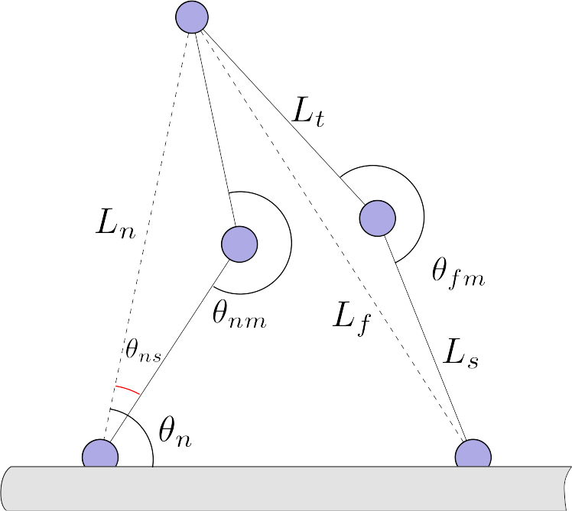Figure 1: Geometry of the Both Bound State
Should I finish this work in a reasonable amount of time, I would like to continue testing our model by adding in extra external forces to simulate the process of carrying cargo. I mentioned previously that there are many studies that have explored the possible forces and torques that dynein exerts. Continued work should explore how our model behaves whilst pulling heavy objects.
Timeline
Fall term
October Verify simulation performance, Literature review
November Fit sim. parameters, Literature review, devise new visualizations
December Fit sim. parameters, Lit review, create outline, draft intro/methods
Winter term
January sim. param. fitting, Write code for external forces
February Finish param. fitting, Test external forces
March Test external forces, draft early results
Spring term
April Finishing gather data, finish results + discussion, final drafting

Data management
Plan for data management (1-2 paragraphs). This paragraph shows that you understand that your data and samples must be appropriately recorded and stored. If you are computationalist, you may generate large amounts of data, so digital storage may need special consideration.

Facilities, Equipment and Other Resources
I will primarily be using my personal laptop for writing and developing code. I will run simulations on the Roundy Research Group computer cluster. Other than that, I also plan to use data on real dynein from Dr. Yildiz (gave a colloquium talk on dynein last year) and Dr. Weihong Qiu’s experimental expertise on measuring motor protein properties.

References Cited
[1] https://www.ncbi.nlm.nih.gov/books/NBK26888/
[2] https://www.ncbi.nlm.nih.gov/pubmed/26436706
[3] https://www.ncbi.nlm.nih.gov/pmc/articles/PMC4129465/
[4] Puls I. et al. 2003. Mutant dynactin in motor neuron disease. Nat. Genet. 33, 455-456. https://www.nature.com/articles/ng1123

